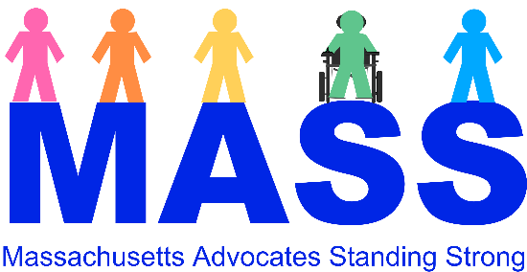

# **SURVIVOR SUPPORT PACKET**

We are MASS Advocates Standing Strong:

Self-advocates in Massachusetts working together to empower ourselves through education, so we can make choices to improve and enrich our lives.

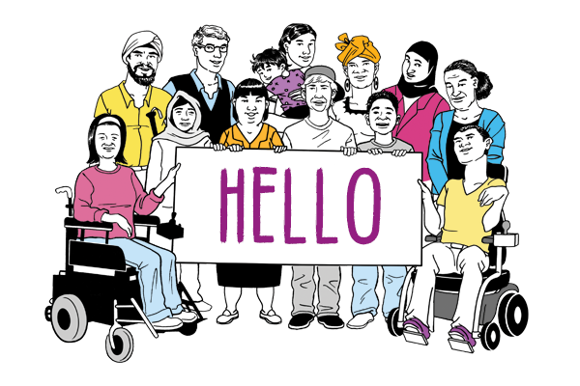

**“Nothing About Us Without Us”**

We know that many people with Intellectual and/or Developmental Disabilities are survivors of sexual abuse.

What is sexual abuse? Sexual abuseis when someone does something sexual to you without your permission.  It can also mean that someone makes you do something sexual to them without your permission. We call the person that sexual abuse happens to, a victim and/or a survivor.

Other words for sexual abuse are sexual assault and sexual violence.

Sometimes, people are not believed when they say they were abused. **We believe you and want to help**.

If you or someone you know is a victim, here is a packet of resources and tools to help with getting support and healing.

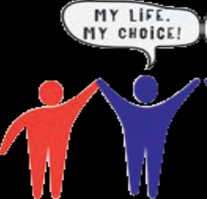**What is in This Packet?**

* **Know Your Rights …… 4**
* **Quick Resource List …. 5**
* **Trust card: Who you can call ………11**
* **Where to get more help:**

**Pathways for Change ……………….12**

**Victim Rights Law Center .….…… 19**

**SAR/DPPC ….………………………..… 30**

* 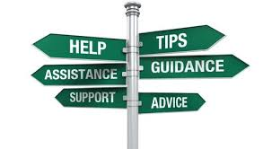**Self-care tools to help ………………. 31**
* **Tips for supporting survivors …….….42**

**Sexual Abuse Survivors Have the Right to Know:**

* Sexual violence is *never* okay, and it is not your fault!
* We believe you!
* It’s okay to

-be afraid or angry

-cry or feel moody

-say NO

-not forgive a person

-love and care for yourself

-speak up about what is best for you

-ask for the support you need



**Additional**

**Supports**

| **Who** | **What** | | **Where** | **How** | **Cost?** |
| --- | --- | --- | --- | --- | --- |
| Mass Advocates Standing Strong (MASS) | We are self-advocates in Massachusetts working together to empower ourselves through education so we can make choices to improve and enrich our lives.  "*Nothing About Us Without US*" | The MASS logo with Massachusetts Advocates Standing Strong in light blue at the bottom. Above that the letters MASS in blue with figures of people in various colors standing on top of the letters including a person in a wheelchair. | All of Massachusetts | WeAreMASS.org  PO Box 560100, Medford, MA 02156 | Free |
| Victim Rights Law Center | Lawyers for the legal needs of survivors of sexual abuse or violence | The Victim Rights Law Center logo with  Victim Rights Law Center written below a seedling that is growing, all in dark teal. | All of Massachusetts | 877-758-8132  or  508-669-7020 | Free & Confidential |
| Pathways for Change, Inc. | Support for sexual abuse, sexual violence, rape in Central MA | Pathways for Change logo with an orange, dark and light teal spiral, followed by "Pathways for Change", the word change in orange, and below it " ending the silence....ending sexual violence," all in teal. | Ashby, Ashburnham, Auburn, Ayer, Barre, Berlin, Bolton, Boylston, Brookfield, Charlton, Clinton, Dudley, East Brookfield, Fitchburg, Gardner, Grafton, Hardwick, Harvard, Holden, Hubbardston, Lancaster, Leicester Leominster, Lunenburg, Millbury, New Braintree, North Brookfield, Oakham, Oxford, Paxton, Pepperell, Princeton, Rutland, Shirley, Shrewsbury, Southbridge, Spencer, Sterling, Sturbridge, Templeton, Townsend, Warren, Webster, West Boylston, West Brookfield, Westminster, Winchendon, and Worcester | Call to speak to a counselor:  **508-852-7600**    For support 24 hours a day, 7 days a week call:  **800-870-5805**  For 24 hours a day, 7 days a week video phone for the **Deaf** and **Hard of Hearing** call support call:  **508-502-7681** | Free & Confidential |
| Disabled Persons Protection Commission (DPPC) | For reporting abuse and/or neglect of people with disabilities | Red Phone that says DPPC Hotline and 1-800-426-9009 and 1-888-822-0350 TTY. Above the phone reads "Report Suspected Abuse of Persons with Disabilities" and below the phone says 24 hours-7days a week, including holidays. | All of Massachusetts | 800-426-9009 or  888-822-0350 TTY | Free & Confidential |
| Sexual Assault Response Team (SAR) | Support after report to DPPC with trauma services to meet the unique needs of victims with disabilities   * Peer Support Specialists | The SAR logo that has a circle cut into 4 quarters that are purple and blue at the top and green and red at the bottom. In the purple it says Information in the blue it says Access in the green it says Education and in the red it says Support. In the middle of the circle it says How We Can Help | All of Massachusetts | [617-727-6465](tel:6177276465) Hotline [800-426-9009](tel:8004269009) | Free & Confidential |
| Rainbow Support Group of Massachusetts | Rainbow Support Group helps members of the LGBTQ community who also have intellectual or physical disabilities find friendship and understanding | Rainbow Support Group of Massachusetts Logo. rainbow colored people standing with rainbow colored words in a rainbow arc above their heads. The first letter of each word spells the word rainbow.The words are respect always appreciate independent nurture believe optimistic and wonderful. | All of Massachusetts | Call:  508-944-5797  Visit: [www.facebook.com/Rainbow-Support-Group-119976291441557/](https://www.facebook.com/Rainbow-Support-Group-119976291441557/) | Free |
| Valley Rape Crisis Center (Wayside) | Support for sexual abuse, sexual violence, rape in Milford & Marlborough area | |  | | --- | | Wayside Youth & Family Support Network logo saying the name and below says "Building Strength, Hope & Resilliency" all written in green. | | Bellingham, Blackstone, Douglas, Franklin, Grafton, Hopedale, Hudson, Marlborough, Maynard, Medfield, Medway, Mendon, Milford, Millis, Millville, Norfolk, Northbridge/ Whitinsville Northborough, Southborough, Sutton, Stow, Upton, Uxbridge, Walpole, Westborough, and Wrentham. | Call:  508-469-3135 and ask to speak to a counselor  24-Hour Confidential Hotline  800-511-5070 TTY  508-478-4205 available  Mon-Friday 9-5 | Free & Confidential |
| Daybreak of the YWCA of Central MA | Support for Survivors of domestic violence | Daybreak YWCA logo with "eliminating racism empowering women above ywca and below "Central Massachusetts" all in orange. | All of Central Massachusetts | Call:  508-755-9030 | Free & Confidential |
| New Hope, Inc. | Support for Survivors of domestic violence | newhope written in black  with "hope" in bold and a drawn sun in orange rising over a cloud of blue and brown. | Charlton, E. Brookfield, Sturbridge, Dudley, Oxford, Douglas, Medway, Milford, Hopedale, Uxbridge, Northbridge, Sutton, Webster, Upton | Call:  1-800-323-4673 | Free & Confidential |

A small card with Trust Card at the top a line and then Name of Person You Trust with Phone # below and a line to write down the number.  Below in the corner is a picture of a woman comforting another woman.  Below the card it says "Who can stand by you when you are getting help?"



**Support for Survivors of Sexual Abuse & Assault**

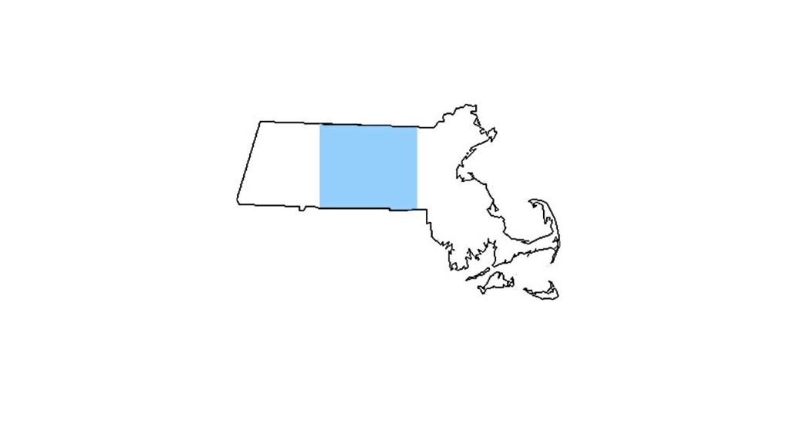Pathways is a **rape crisis center** (RCC) in **Central Massachusetts**. If you don’t live in Central Massachusetts, Pathways can help you find an RCC near you.

**Pathways Services:**

* Pathways believes your **privacy** is important. All services are **Confidential and Free.**
* **Sexual abuse and assault** is when someone does something sexual to you without your permission. It can also mean that someone makes you do something sexual to them without your permission. Pathways also knows that words hurt too, which includes any unwanted sexual comments or talking to you in a sexual way, without your permission.
* Pathways supports survivors no matter when the sexual abuse or assault happened. Whether it was yesterday or years ago, we are here to support you.
* Pathways services available during the day include:
  + 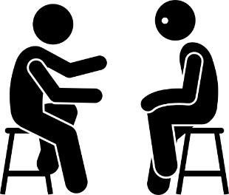**Face to Face Support:** Counselors can connect with you, in a private and safe space, so you can talk and share your thoughts without others around to see or hear. If you would like to learn more about meeting with a counselor, call our main office (508-852-7600) and ask to speak to a counselor.
  + **Support Groups:** Pathways have group counselors who can provide a private and safe space forSurvivors who may want to meet with other Survivors to get/give support. If you would like to learn more about group support, call our main office (508-852-7600) and ask to speak to a counselor.
  + **Support at Court**: When a Survivor has reported to the police about being sexually abused or assaulted, they may need to go to court at some point. **Pathways Advocates** are available to meet them at the courthouse to provide support. If you need support in the courts, call our main office (508-852-7600) and say: “I would like to speak to an **Advocate.**”
  + The Victim Rights Law Center logo with  Victim Rights Law Center written to the right of  a seedling that is growing, all in dark teal.**Referrals:** Sometimes Survivors need more support than just from Pathways. **Pathways Counselors** can help connect you to other agencies, like the **Victim Rights Law Center**.
  + To learn more, call our main office (508-852-7600) and say: “I would like to speak to a **Counselor**”.
  + 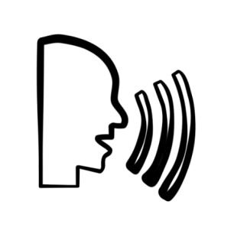To get services at Pathways, you can call the main office during the day, **508-852-7600** and ask to speak to a counselor.
* 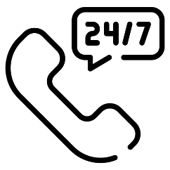Pathways has other services that are available24 hours a day, 7 days a week
  + 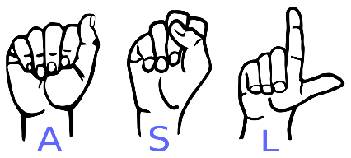**Hotlines**: Call **1-** **800-870-5905** and if someone is Deaf or Hard of Hearing and uses **American Sign Language** Pathways has a Video Phone Hotline: **(508) 502-7681**.
  + To talk to a Counselor any time of day or night, call the hotline number and say: “I would like to speak to a **Counselor**”.
  + 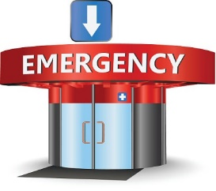**Support in the Emergency Room:** When a Survivor has just been sexually abused or assaulted they may want to go to the emergency room.

**Pathways Advocates** are available to meet them at the emergency room to provide support.

* + If you need **support in the emergency room**, call our hotline number and say: “I would like to speak to an **Advocate**”.
  + **Support at the Police Station**: If a Survivor has been sexually abused or assaulted they may want to go to talk to the police. **Pathways Advocates** are available to meet them at the police station to provide support.
  + If you need **support at the police station**, call the hotline number and say: “I would like to speak to an **Advocate**”
* Pathways Advocates also support survivors’ family, partners, spouses and/or friends, who you feel comfortable with. We can help them learn how to be a good support for you.

**The Victim Rights Law Center logo with  Victim Rights Law Center written to the right of a seedling that is growing, all in dark teal.**

**Help for Survivors of Sexual Assault**

**Call us at: 508-669-7020**

Leave a message and we will call you back.

**WHO do we help?**

The Victim Rights Law Center provides **free** and **confidential** help to survivors of sexual assault. **Confidential** means we won’t tell anyone your private information.

**Sexual assault** is when someone does something sexual to you without your consent.  It can also mean that someone makes you do something sexual to them without your consent.

**Consent** means that you agree to or give permission for something you want to do. It is not consent if you do something because you are afraid or because someone forced you. Even if you agree to one thing, you can still not agree to something else. You can also change your mind at any time.

**Sexual assault** can happen to anyone. It can happen in a romantic relationship. If can also happen outside of a romantic relationship. The person who hurts you can be someone you know, like a friend or caretaker. It can also be someone you do not know.

We call the person that this happens to a **survivor** or a **victim.**

**HOW can we help?**

Please read the following pages to learn more about our services.

**Privacy**

* If something is private, you might not want other people knowing it. In a criminal case, the person who hurt you will have a lawyer. That lawyer may try to get your private information. This could be information your doctor, school, or someone else has about you. We may be able to help keep your personal information private.
* We can talk about how to protect your privacy in all areas of your life, such as at school, work, a program, and in the courts.
* We can also talk to you about how to keep your information private online.



**Safety**

* You may want a **restraining order** from a court. That order would say that the person who hurt you must stay away from you and not hurt you again.
* If you want, we can help you ask a court for a restraining order. We can also help you talk to the judge when you go to court for a restraining order.
* We may be able to help you get a **no trespass order** for your school, work, home, day program, or where you spend your time. A no trespass order means the person who hurt you must stay away from that place.



**School**

* We may be able to help you get special education services from your school.
* We may be able to help you keep the person who hurt you away from you at school.
* If you were assaulted at school, your school might look into what happened. They might call this a “**disciplinary process**” or a “**Title Nine investigation**.” The school might want to ask you questions. They might want to punish the person who hurt you. If this process happens, we may be able to help you through it.

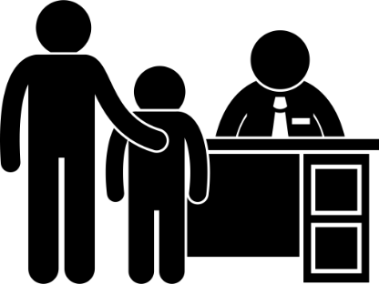

**Immigration**

* VRLC also helps survivors who are not citizens of the United States. If you are not a United States citizen but you want to stay here, we may be able to help.

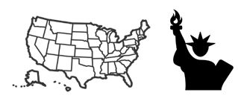

**Work**

You may not feel safe at work. You may want to take time off. You may want to change your work schedule. There could be other things you need at work. We may be able to talk to someone where you work to help with any of these things.



**Public Benefits**

* Public benefits we may be able to help you with are:
  + - SSI/SSDI (Social Security)
    - SNAP (food stamps)
    - DTA Cash Assistance (TAFDC/EAEDC)
    - Unemployment Insurance (UI)
* If you are not getting a public benefit that you could be getting, then we can tell you where and how to apply for it.
* If you applied for benefits and did not get them, we may be able to help you.
* If there is something wrong with a public benefit you are already getting, we may be able to help you try to fix it.

**Where You Live**

* You might not feel safe where you live. You may want to move or change the locks on your door. You may want to do something else to feel safer. We may be able to help with those things.



* Sometimes, landlords try to evict people. Evict means someone makes you move out of your home. We may be able to help you stay in your home.

**There are some things we cannot help with:**

* We do **not** help with family law issues. This means divorce, child support, child custody, and parenting time.
* We do **not** help survivors sue the person who hurt them for money.

**If we are unable to help you, we will do our best to refer you to someone who can.**

**What to say when you call the VRLC:**

**You can read from this when you call. Fill in the blank space or check the box you want to use.**

Hi, my name is ____________________________.

Your name

I live in _______________________.

Name of your Town

**I was sexually assaulted.**

My phone number is _____________________.

It is best to: ☐ Call me ☐ Text me ☐BOTH call and text

A safe and okay time to call or text me is ________________

**I need help with:**

☐ My Housing (where I live)

☐ Immigration

☐My School

☐ My Privacy

☐ My Safety (I don’t feel safe)

☐ Something else _________

☐ I’m not sure/ I don’t know

**It is okay if you do not know what you need help with!**

**Fill in below ONLY if you have something happening in court soon. Please also leave this information in your message**

I have to go to court soon.

The date of my court hearing is _______________.

Date

It will be at ______________________ court.

Name of court

**If you want to, please tell us if you have a disability.**

**Let us know if there are any accommodations or help you need, for us to best support you.**

**Disabled Persons**

**Protection Commission**

**Sexual Assault Response Team**



**To report suspected abuse or neglect**

**against a person with a disability,**

**please call the**

**Disabled Persons Protection Commission**

·

Hotline

**800**

**-**

**426**

**-**

**9009**

(24 hours a day/7 days a week)

·

For sexual abuse victims with

disabilities

·

Supports victims in connecting to trauma services and working

through challenges such as communication, transportation and

accessibility

·

The goal is to make sure that victims and others are informed

of service options that can meet the unique

need of victims

with disabilities

·

After hours response is available on the 24/7 hotline

·

Statewide

·

Services offered in English and Spanish

*DPPC does not discriminate on the basis of race, color, national origin, religion, sex, disability, age, sexual orie*

*ntation, or gender identity in*

*the provision of services.*

*“*

*This project was (partially) supported by the Massachusetts Office for Victim Assistance through a Victims of*

*Crime Act of 1984 (VOCA) grant from the Office for Victims of Crime, Office of Justice*

*Programs, U.S. Department of Justice*

*”*

**How We Can Help**

**Information**

**Access**

**Education**

**Support**

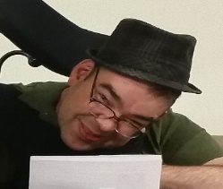**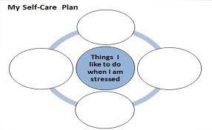Self-Care Tools**

* 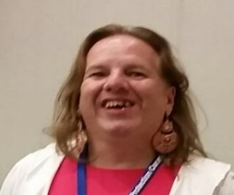**When I am stressed videos:**
* 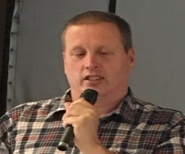**[John Mullaly's Yoga and Breathing Video](https://youtu.be/E056qvneDr4)**

**(https://youtu.be/E056qvneDr4)**

* **[Brian Kelly Using Music to Help](https://youtu.be/WTcR_r0biXE)**

**(https://youtu.be/WTcR_r0biXE)**

* **[Pauline Bosma and Her Pet Bunny](https://youtu.be/4g0AF-SXmrY)**

**(**[**https://youtu.be/4g0AF-SXmrY**](https://youtu.be/4g0AF-SXmrY)**)**

* [**Listen to a Relaxation Exercise**](https://drive.google.com/file/d/1qUYeeIdsJ2xjVPK_W93Ww-SsXRUQfHxg/view?usp=sharing)

(https://drive.google.com/file/d/1qUYeeIdsJ2xjVPK_W93Ww-SsXRUQfHxg/view?usp=sharing)

* [**Relaxation Exercise with Subtitles**](https://www.youtube.com/watch?v=Y1t4XUQ7-cc&feature=youtu.be)

**(https://www.youtube.com/watch?v=Y1t4XUQ7-cc&feature=youtu.be)**

* **Take Time for Yourself…………………………….…..32**
* **Coming Back to Center Exercise…………………..33**
* **Relaxation Exercise ……………………….….……….34**
* **Relaxation Exercise – Short ……………………..….37**
* **Putting Hard Stuff Away Exercise…………………………………………….……….39**
* **Tips for Survivors …………………………..……………42**

**Take Time for Yourself**

**Get Moving Play a Game**

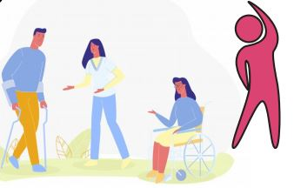

**Do A Project Journal Your Feelings**

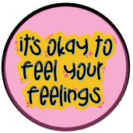

 **Listen to Music Reach Out to Someone You Trust** 

**Coming Back to Center Exercise**

**Are you feeling overwhelmed and need to center yourself and re-group? Try this to feel back in balance…**

Sit in a chair and breathe. Notice the air moving in and out of your nose and mouth as you breath….does it make a sound? Can you feel the air? Is it warm? Is it cool? What do you notice about it?

Look around the room you are in….what do you see? Is there a chair in the room? What color is it? Does it look soft or hard? What else do you notice in the room you are in? Keep breathing, in and out, as you notice the floor under you. What colors do you see? Are there any sounds in the room? Are there any smells in the room? What color are the walls? Is there anything hanging on them? How big is the poster or the picture on the wall that you see? Is there a light switch on the wall? Does it flip up and down, or side to side?

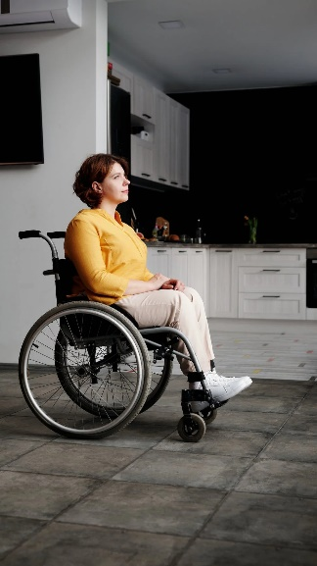Notice the chair you are sitting in…..is it firm under you? Is it soft? Does it support your back? Is it cold or warm? What color is it? Can you feel yourself sitting in the chair, is anything touching your arms as you sit in your chair?

Now after you have breathed a bit, and noticed the space around you and you in it, how do you feel? Are you a bit more centered? Can you focus a bit more easily now on what you wanted to?

If not, try one of the breathing exercises also listed in our support section.

**Relaxation Exercise**

Find a quiet space that is private enough to take 3 minutes to take care of your mind and body.

Ready???

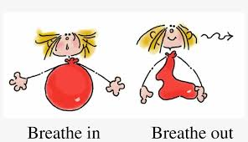Focus on the floor in front of you about 6 feet away from your feet, pick a spot and focus on that spot….or where the floor meets the wall in front of you, if you are in a small space… focus on that spot….hard….breathe out….all the air you have in your lungs, hard……then when there’s no air left, breathe in, a full good breath….do it a few times, if you need to do a few more, go ahead….you’ll know….

When you are focusing on that spot and are breathing normally, then start to pay attention to your head, the top of your head and your scalp. As you breathe, ….in through your nose, focus on the top of your head, and around the back of your head, …feel any stress, or tension, and as you breath out through your mouth, feel any and all stress from the top of your head go out with your breath.

Keep breathing in through your nose, and out through your mouth….and now focus on your whole head, as it rests on your neck, feel the tension and any stress in there, keep breathing….in through your nose, and out through your mouth….and now take any heaviness, and tension you’ve found in your neck and head and breathe it out of your mouth….letting go of all stress, pain, fatigue, tension, weight, whatever you find, that you don’t want in there… breathe it out….through your mouth….

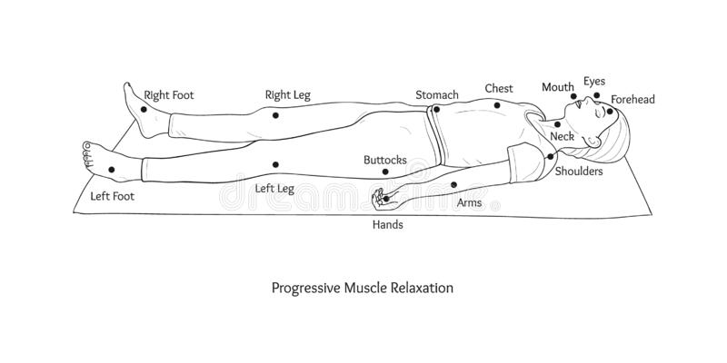Now keep going down your body with your attention, as you breathe nice and evenly, in through your nose, and out through your mouth… stopping at the shoulders, and back, feeling any pain, stress, tension and let it release with your breath…out through your mouth….

When ready keep going down your body, to your belly and your hips, your knees, calves, and all the way down, stopping anywhere you feel stress, tension, tiredness, and let it go with your breath…out through your mouth….

When you get to your feet….feel any pain, stress, tension, you want to move out of your feet and this time let it go out through the bottom of your feet into the ground beneath you, as you breathe out. Then check if there is anything left in your body that the first go around didn’t find and …feel all the stress, hurt, pain, and tension leaving your muscles, and your body, and breathe out of your mouth as you picture it all going out from the bottom of your feet, and into the ground….keep breathing, in through the nose, and out through the mouth… and now feel how you’re doing….

Do a check-in…. feel less stressed? Less tired? Feel more grounded? How’s your body feel? How long did that take? For me it’s usually about 3 minutes, and I’ve gone through every muscle …. But when it’s a really hard day, I sometimes, have to go back to my shoulders and neck again to really feel looser, and calmer…

3 minutes is worth the time to get rid of a ton of stuff you’re carrying around in your muscles, it lightens the load!



**Relaxation Exercise: The Short Version**

Find a quiet and private space to do this exercise.

Focus on a spot on the floor in front of you about 6 feet away from your toes. Stare at that spot and breathe out all the air in your lungs, and then breathe in, a full good breath. Keep doing this until you are focusing on that spot and breathing normally.

Now as you pay attention to different areas of your body, breathe in through your nose and out through your mouth, in nice, even, slow, breaths. Keep breathing this way through the whole exercise.

As you breathe deeply and slowly, first pay attention to your head, and focus on your forehead. Notice any tension or stress in your muscles, and as you breath out, let go of any of the tension you have found in and around your head. Now focus on your eyes and then your mouth. As you breathe in through your nose let all that stress and tiredness go out through your mouth with your breath, letting it go. Keep breathing slowly and deeply all the way through.

Now focus on your neck and shoulders. As you breath, in and out, feel any pain or stress or tension in those areas and breath it out with your breath.

Now move on to your chest. Feel any tension, tightness, stress and let it go as you keep breathing and let the tension go out with your breath.

Now focus on your arms and hands. Keep noticing any tension, strain, pain, and let it go as you keep breathing in through your nose and out through your mouth.

Now move to your stomach and notice any upset, any stress or tension and let it go out with your breath. As that feels better, move to your hips and back side. Let go of any stress or pain or tension in those areas as you again breath it out through your mouth.

Keep moving your attention down your body to your thighs, and then your calves, and then to your feet. Stop at each area and see if there is any tension or stress or pain that you want to breath out of your body. When you finish with your feet, do a scan of your whole body. See if there are areas that need more attention and if you find them, keep breathing in through your nose and then let go of the stress as you breathe out through your mouth.

This usually takes people about 3 minutes to go through their whole body. 3 minutes is worth the time to get rid of a ton of stuff you’re carrying around in your muscles, it lightens the load!



**Putting Hard Stuff Away Exercise**

**Do you have a situation you just can’t stop thinking about and is getting in the way of focusing on what you want to be doing? Try this to help…**

First sit in a comfortable seat with both feet on the floor, if this is possible for you, and sit up as best you can, so you can breathe fully and deeply.

Now, let’s help you to put that situation or thing that won’t let you focus on what you want or need to do, in a safe place, to deal with later, when you do have time and support to be able to work on it.

Now that you are sitting comfortably and have made space in your body to let you breathe as best you can….let’s practice… 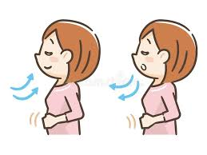

Breathe in through your nose, and then breathe out through your mouth….

Try doing that a few times to make sure you are breathing as smoothly and deeply as you can, and that your body is comfortable.

Breathe in through your nose, and then breathe out through your mouth…. keep doing that….

Now as you sit comfortably, breathing nicely, picture a trunk. The one I see in my mind is big, and red, and made of wood, with metal straps all over it. What do you want the trunk that holds your stuff for later to look like? Can you see it? Can you imagine it? Mine is big and heavy, what is yours?

Once you have a good idea of what your trunk looks like, put a lock on it. Make sure it’s secure for only you to open. My lock looks like a big metal one with a huge keyhole….my friend uses a combination lock for hers…..someone else uses their fingerprint to open theirs, what does yours look like? Make sure it can lock your trunk….

Now…. keep breathing in through your nose, and out through your mouth…sitting comfortably, in your chair….

As you breath, now take that situation, you keep thinking about, or that you know about but don’t have time to work on right now, and put it in your trunk….

Do you have enough space in there? Make sure your trunk fits it all nicely….

Sometimes your stuff doesn’t want to be held off,

…. If it’s hard to keep it in the trunk, just tell it you are keeping it safe to deal with when you can. That when you are in a better place to look at it, or deal with it, you’ll open it up and work on it. But for now, it’s safe and away. Lock it up to be sure.

Now, just keep being comfortable, in your chair, and breath, as you look at the trunk. What color is it? What is it made out of? The lock is secure and you can open it when you want to. You can now put things away in your trunk or bring it up when you want to, and now you have control over it, not the other way around.

Breathe in through your nose, and out through your mouth, a few more times, to get used to your stuff away, safe, in a trunk, for later….In through your nose and out through your mouth….

Now you are more ready to go do what you want or need to do. You now have a place to put stuff when it comes up, to deal with when you have the support and whatever help you need, to deal with it. Now, you can better manage your day…

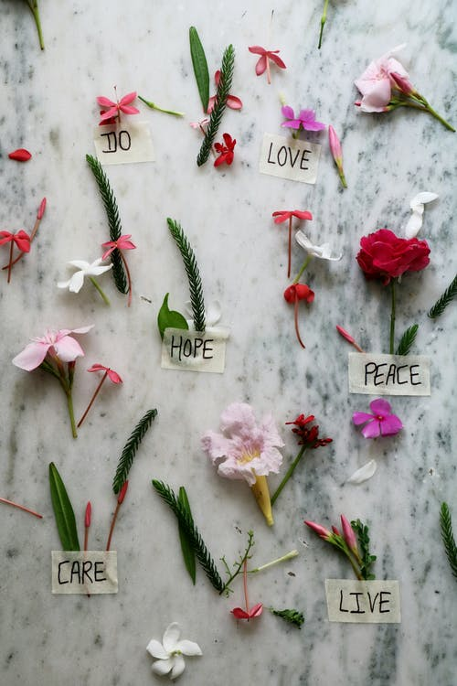

**Tips for Supporting Survivors**

**Share these with people who can support you. You have a right to be treated with respect.**

* ***Let the person be in control***: When a person is sexually assaulted control is taken away from them. It is important that you do not make decisions for the survivor, but rather let them decide as much as possible for themselves.
* ***Be supportive****:* Do not ask them for details about the assault but communicate your willingness to listen. Do not promise more than you can give. It is better to be realistic than not to follow through.
* ***Encourage Action****:* Let them know they have options. They can get medical attention and also seek counseling. They may want to file a report with the police. All options are up to them, and this has to be their decision and no one else’s. If they are not interested in any of these options, respect them for that.
* ***Be reassuring****:* Remind them that rape/sexual assault is never the survivor’s fault. The two most important messages that you should tell a survivor are:

“I believe you” and “This is not your fault”

***Other suggested phrases are:***

“I’m sorry that this has happened to you.”

“You didn’t do anything wrong.”

“What do you need? What can I do to help?”

“This does not change how I feel about you.”

“I appreciate how hard this must be for you to tell me this.”

* ***Get support for yourself***: Sexual Assault is a difficult issue and can affect those who care about the person who has been victimized. You can call a 24-hour hotline for support for you and the survivor.

This project is supported by Grant No. 2017-FW-AX-K004 awarded by the Office on Violence Against Women, U.S. Department of Justice. The opinions, findings, conclusions, and recommendations expressed in this publication/exhibition are those of the author(s) and do not necessarily reflect the views of the Department of Justice, Office on Violence Against Women.